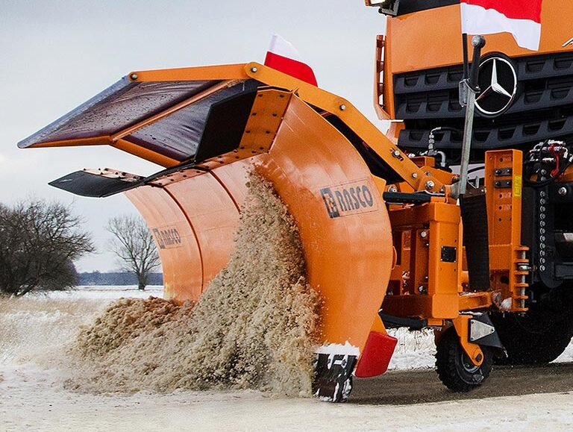

RASCO Snow Plough Enquiry Form

Name: ________________________
Company: ________________________
Address: _______________________________________________________________

Please select answers below with regard to your enquiry:
Please select from the following: MOSOR PK MSP VERTUS VITER KALNIK KALNIK XL BILO KOMBI
Truck Type: ________________________
Body Length: ________________________
Body Width: ________________________
Mode of Transport: ________________________
Gross Vehicle Weight: ________________________
Model Number: ________________________
Market: ________________________
Time frame for supply: ________________________
New/ Used equipment: ________________________
Comments:

Once complete, please return this form to harsh@harshuk.com and one of our team will be in touch to discuss your requirements.

